ll.net

产 品 规 格 书
NI-MH BATTERIES SPECIFICATIONS
产品型号(MODEL NO.)： GMCELL-60DJ6000mAh 1.2V
文件标号(FILE NO.)： GMCELL 17-AS1-04-25-MH-034
客户编号(CUSTOMER NO.)：

规格书审批  Specification Approved | 制定  PREPARED | 范茂露
规格书审批  Specification Approved | 审核  CHECKED | 祝东贵
规格书审批  Specification Approved | 批准  APPROVED | 李兴松

客户审批  Customer Approved | 审核  CHECKED
客户审批  Customer Approved | 批准  APPROVED
客户审批  Customer Approved | 请签名盖章确认后回传我司  Please sign and return one copy to us | 盖章处  Seal the

高巨能公司保留在没有预先通知的情况下改变和修正设计及规格说明书的权力。
GMCELL reserve the right to alter or amend the design, model and specification without prior notice.

深圳市高巨能科技有限公司
SHENZHEN GMCELL TECHNOLOGY CO., LTD
电话(TEL)：+86 0755-29497371
传真(FAX)：+86 0755-23703178 邮编(POST CODE)：518101
地址：广东省深圳市宝安区新安街道27区前海华联全景国际G栋G2205&G2206
ADD: Room G2205-G2206,Hualian Panorama International Building,27 District Bao’an, Shenzhen.
E-mail: gmcell@gmcell.net

http://www. gmce

目 录
Content
1.修订履历 Modified List ………………………………………….3
2.适用范围 Scope …………………………………………………..4
3.型号 Model ………………………………………………………..4
4.外观 Appearance…………………………………………………4
5.规格性能检测 Ratings …………………………………………...4
6.常规性能 General Performance……………………….……….4
7.环境性能 Environment Performance.…………………………5
8.安全性能 Safe Characteristic…………………………………..5
9. 单体电芯尺寸Specifications of single cell…………………..6
10.充放电特性 characteristic of charge/discharge……………7
11.保证期 Quality guarantee period …………………………….8
12.注意事项 Cautions………………………………………………8
13.警惕与防范Guard…………………………………………..9/10/11

- 修订履历
Modified List

产品变更履历表
Product Modified Record List

版本  Revision | 日期  Date | 标记  Mark | 变更内容  Modified Content | 批准  Approved
V2.0 | 25/04/2017

2. 适 用 范 围(Scope):
本说明书用于本书中涉及的深圳市高巨能科技有限公司的镍氢电池产品。
This specification is applied to the reference battery in this Specification and manufactured by SHENZHEN GMCELL THCHNOLOGY CO., LTD.
3、型 号(MODEL)： FB-60DJ6000mAh 1.2V
4、外 观(APPEARANCE):
电池/电池组外观无破裂、划痕、变形、生锈、污迹、电解液泄漏等不良现象。
The cell / battery shall be free from cracks, scars, breakage, rust, discoloration, leakage and deformation.
5、规 格、性 能 检 测(RATINGS):
以下项目作为评估电池的基本指标，可根据需要对电池进行测试。
Table below can be taken as the basic guideline of evaluation the battery quality.
5.1 环境温度(ambient temperature)20±5℃，相对湿度(Relative Humidity): 65±20%
5.2 测试工具要求满足(Testing facility must conform to the condition)：
电流表:IEC 51/IEC 485所规定的0.5级或以上。包括引线总电阻小于0.01Ω
Ampere meter: IEC 51/IEC 485 stipulated grade 0.5 or above, including the down-lead resistance totally less than 0.01Ω
内阻仪:交流1KHz正弦波4端子测量设备
Resistance tester: AC 1 KHz sine wave 4 terminals testing equipment
6、常 规 性 能（General Performance）:
项目  Item | 规格  Specification | 条件  Conditions
标准充电  Standard charge | 600 mA（0.1C） | 环境温度20±5℃，相对湿度: 65±20%  ambient temperature of 20±5℃, Relative Humidity: 65±20%
标准充电  Standard charge | 16 hrs
标准放电  Standard discharge | 1200 mA (0.2C) | 标准充电后，放电截止电压1.0V  standard charge, the final voltage is 1.0V
快速充电  Rapid Charge | 3000mA（0.5C） | -ΔV=5～10mV环境温度20±5℃，相对湿度: 65±20%  ambient temperature of 20±5℃, Relative Humidity: 65±20%
快速放电  Rapid discharge | 3000mA（0.5C） | 标准充电后，放电截止电压1.0V  standard charge, the final voltage is 1.0V
涓流充电  Trickle Charge | 120～300 mA  (0.02C～0.05C) | Ta=-10～45 ℃
标称电压  Nominal Voltage | 1.2 V
开路电压  Open circuit voltage | ≥ 1.25V | 标准充电后，1hrs内测量  Within 1 hr after standard charge
标称容量  Nominal Capacity | 6000 mAh
最低容量  Minimum Capacity | ≥6000 mAh(0.2C) | 标准充放电.  Standard charge and Standard discharge
最低容量  Minimum Capacity | ≥5700 mAh(0.2C) | 标准充电快速放电.  Standard charge and Rapid discharge
内阻  Internal Impedance | ≤20mΩ | 标准充电后,一小时内测量  Within 1 hr after standard charge
荷电保持率  Charge-retention Rate | 荷电保持率≥标称容量60%(3600mAh)  Charge retention rate ≥Nominal capacity 60%(3600mAh) | 标准充满电后贮藏28天，标准0.2C放电至1.0V  Storage a period of 28 days after standard charge, then Standard discharge (0.2C) to 1.0V
循环寿命  Cycles Test | ≥ 500 Cycles | IEC61951-2:2003 （see note 2）
7、环 境 性 能（Environment Performance）:
储存温度  Storage Temperature | Within 1 year | -20～25℃
储存温度  Storage Temperature | Within 6 months | -20～35℃
储存温度  Storage Temperature | Within 1 months | -20～45℃
储存温度  Storage Temperature | Within 1 week | -20～55℃
使用环境温度  Operation Temperature | Standard charge | 15～25℃
使用环境温度  Operation Temperature | Fast Charge | 0～45℃
使用环境温度  Operation Temperature | Discharge | 0～45℃
恒定湿热性能  Constant humidity and hot performance | 不坏损  No damage | 标准充电后, 在温度33±3℃，湿度80±5%的环境中放置14天。Full charge the battery at current 0.1C, 33±3℃，80±5%R.H., storage 14 days.
8、安 全 性 能（Safe Characteristic） :
过充电特性  Over-charge | 无变形无漏液;容量大于等于额定容量.  No leakage nor explosion apacity≥100% | 将电池以0.2CmA放电至1.0V，先标准充电，再以0.1CmA充电48小时后，以0.2CmA放电，测定电池容量。  0.2C discharge to 1.0V , 0.1C charge for 48 hrs, then test the Capacity with Standard discharge Conditions
过放电特性  Over-discharge | 无变形无漏液;容量大于等于额定容量80%。No leakage  nor explosion  Capacity≥4800mAh | 将电池以0.2CmA放电至1.2V，然后将电池串联负载1Ω，经24小时后，再将电池按标准充电标准放电后测定电池的容量。  0.2C discharge to 1.2V,Cornbine the battery with a 1Ω electric resistance, after stored for a period of 24 hrs, then test the Capacity with Standard discharge Conditions
振动测试  Vibration Test | 电压变化:≤0.03V/只  内阻变化:≤5 mΩ/只  Voltage variety:  ≤0.03V/cell  Internal impedance:  ≤5 mΩ/cell | 0.1C充电16小时，搁置24小时，振动前后检测电池.振动条件:  振幅1.5mm,频率3000CPM,任意方向振动60分钟  Charge at current 0.1C for 15hrs; place for 24 hrs, check the battery before and after vibration. Vibration condition: Swing: 1.5mm, Frequency: 3000CPM, Vibrate for 1hr to any direction.
自由跌落  Drop Test | 电压变化:≤0.03V/只  内阻变化:≤5 mΩ/只  Voltage variety:  ≤0.03V/cell  Internal impedance:  ≤5 mΩ/cell | 0.1C充电16小时，搁置24小时，落下前后检测电池；冲击条件:从1.5m高处任意方向自由落下三次,落至木板表面（厚度10mm）.  Charge at current 0.1C for 15hrs, place for 24 hrs, check the battery before and after fall down test; Impact condition: Fall down from height 1.5m to any direction on the hard-wood board( Thickness:10mm), test for 3 times
安全性  Safety | 无破裂或爆炸,但允许漏液和变形.  No disrupt or burst, explosion, but leakage of electrolyte and deformation are acceptable | 电池在环境温度20±5℃下以恒流0.2I_{t}A强制放电至0.0V,然后将电流提高到1.0I_{t}A,并在相同环境温度下继续强制放电60分钟.  The battery shall undergo a forced discharge in an ambient temperature of 20±5℃,at a constant current of 0.2I_{t}A,to a final voltage of 0V.the current shall then bi increased to 1.0I_{t}A and the forced discharge continued in the same ambient temperature of 20±5℃,for 60 min.
短路测试  External Short Circuit | 不着火不爆炸  No fire and no explosion | 标准充电后，在20℃±5环境中用超过0.75mm²金属丝将单颗电池短路至电池恢复到常温。  After standard charge, short-circuit the cell at 20℃±5℃ until the cell temperature returns to ambient temperature.(cross section of the wire or connector should be more than 0.75mm²)

9、单体电池尺寸(Specifications of single cell):
TYPE | Nickel-Metal Hydride cylindrical single cell |  | unit: MM  d  Φ33.0-1.0  H61.5-1.0  Φ8.0±0.05
MODEL | GMCELL- 60DJ6000mAh 1.2V |  | unit: MM  d  Φ33.0-1.0  H61.5-1.0  Φ8.0±0.05
Dimensions | diameter | 33.0-1.0mm | unit: MM  d  Φ33.0-1.0  H61.5-1.0  Φ8.0±0.05
Dimensions | Height | 61.5-1.0mm | unit: MM  d  Φ33.0-1.0  H61.5-1.0  Φ8.0±0.05
10、充放电特性(characteristic of charge/discharge):
Note 1: 标准充放电. Standard charge and Standard discharge
Note 2: (1). Ambient temperature: 20±5℃, Relative Humidity: 65±20%
(2). IEC标准循环寿命测试方法 (Life test method of IEC61951-2:2003) ：
Cycle Number | Charge | Stand in charged condition | Discharge
1 | 0.1C×16hrs | None | 0.25C×2hrs 20min
2~48 | 0.25C×3hrs 10min | None | 0.25C×2hrs 20min
49 | 0.25C×3hrs 10min | None | 0.25C to 1.0V/ cell
50 | 0.1C×16hrs | 1～4hrs | 0.20C to 1.0V/cell
重复1至50次循环,直至某一第50次循环的放电时间少于3小时
Cycles 1 to 50 shall be repeated until the discharge duration on any 50th cycle become less than 3h.At this stage, a repeat capacity measurement as specified for 50 shall be carried out

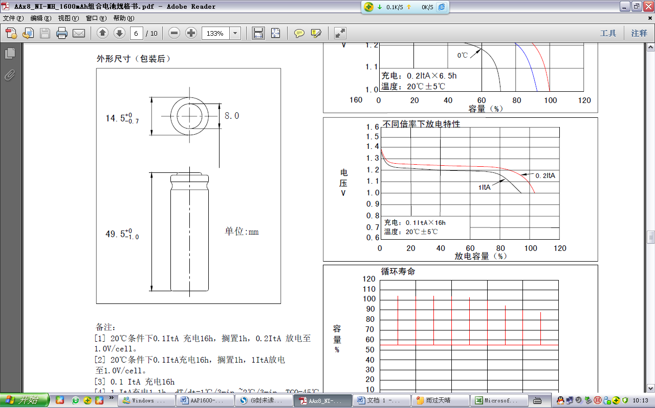

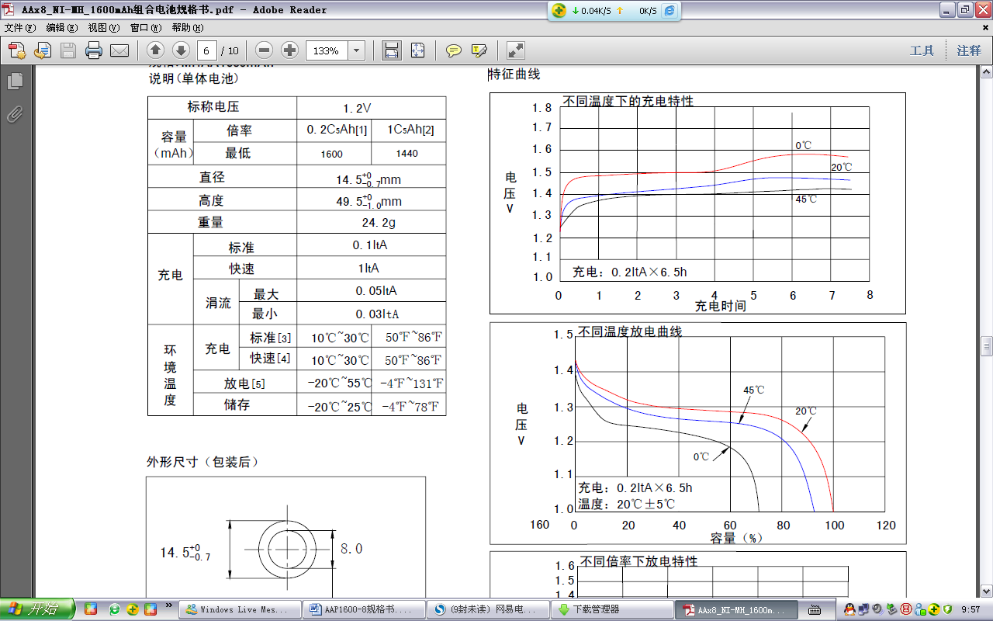

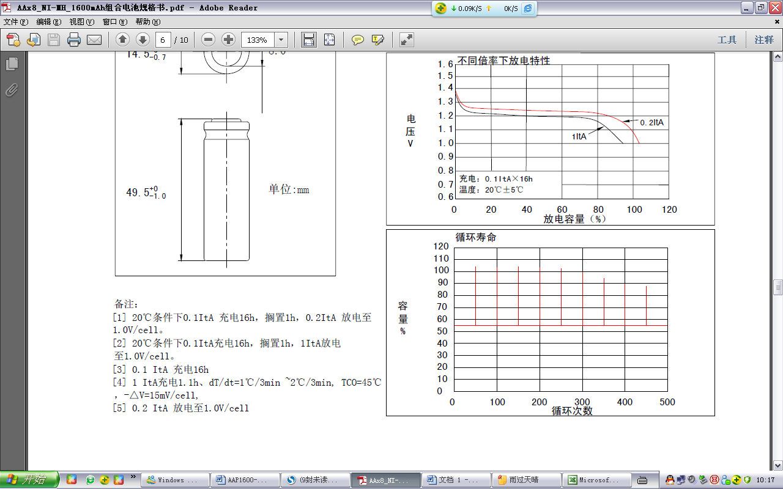

11、保 证 期(Quality guarantee period):
电池保质：12个月.
建议：本公司产品在出厂时根据运输距离和包装条件已充20-80﹪的电量，贵公司在检测容量时，
先用0.2C放电至1.0V/只；再标准电流充放，进行容量检测、补充电。如果库存时间有3个月或以上的，先用0.2C放电至1.0V/只，然后用0.1C充电16hrs，搁置20min，以0.2C放电至1.0V/只，经活化后；再标准电流充放，进行容量检测。首次使用时建议采用标准充电法充电,以免对电池造成伤害。
Guarantee time for one year due to the processing and raw material defectiveness.
Suggestion: The products before delivery would be charged 20-80% capacity according to the transportation distance and packing condition. While checking the capacity, please discharge the battery at 0.2C to 1.0V/cell; then charge and discharge the battery at by standard current. If the storage time over 3 months or above, please discharge the battery at the current 0.2C to 1.0V/cell, then charge the battery at 0.1C for 15 hours, after that place for 20mins, discharge the battery at 0.2C to 1.0V/cell. After this activation, check the capacity by the standard current charge and discharge the battery. The first time use suggested to take standard charge method to charge the battery to prevent from damage to battery.
12．运输、储存(Transport、Storage)：
- 12.1 运输(Transport)：
- 电池在运输过程中应保持在清洁、干燥、通风的环境，并防止剧烈振动、冲击或挤压，
- 防止日晒雨淋，可使用汽车、火车、轮船和飞机等交通运输工具。
- Batteries should be kept in a clean dry and ventilated environment in the process of transportation，And to prevent violent vibration impact or pressure，Prevent the sun and rain，Can use the auto train ships and aircraft and other means of transportation
12.2 储存（Storage)：
12.2.1 储存的温度与湿度（Temperature and humidity storage）：
电池应储存在环境温度为-20℃~35℃，相对湿度不大于85%的清洁、干燥、通风的室内，应避免与腐蚀性物质接触，应远离火源及热源。
The battery should be stored at ambient temperature for -20℃~35℃，The relative humidity is not more than a clean and dry 85% indoor ventilation，Should avoid contact with corrosive substances，We should keep away from fire and heat source。
12.2.2储存的放置方式（Placed way storage）：
成箱电池堆放最高层数请勿超过五层，为保证电池箱之间有良好的空气流通状态，请保持纸箱间5～10cm以上距离， 防止电池因堆积聚温而引起安全事故。
Batteries stacked layers of boxes of highest do not exceed five layers，In order to ensure good air circulation between the state of the battery box, Please keep box between 5 ~ 10cm distance, Prevent battery due to the deposition temperature gathering and cause safety accident。
13、警惕与防范(Guard):
为防止因电池影响造成设备故障，确保电路及电池配套使用安全。在设计和生产设备的时候，请充分考虑以下事项，并将其纳入到说明书中。
In order to prevent from battery effect caused by equipment failures, Ensure that the circuit and battery set of safety. In the design and production equipment, Please give full consideration to the following matters, And consider the specification.

△注意（Note）：
!
- 电池在使用前必须充电.
Batteries should be charged prior to use.
- 所有的快速充电方法应与我们的工程师讨论
Fast charging method of all should be discussed with our engineer.
- 在使用新电池前，或者长期存放后第一次使用电池，在使用前请将电池充满电.
When using a new battery for the first time or after long term storage, please fully charge the battery before use.
- 充电方法请参考我们的规格书.
For charging methods please reference to our specifications.
- 使用Ni-Cd 或 Ni-MH专用充电器.
Use the correct charger for Ni-Cd or Ni-MH batteries.
- 将电池贮存在阴凉干燥处.
Store batteries in a cool dry place.
- 当把电池放入充电器中时，注意保证极性正确.
When connecting a battery pack to a charger, ensure correct polarity.
- 当电池不使用时，请把它从装置上取下.
When not using a battery, disconnect it from the device.
- 经过长时间存放，电池应每三个月进行一次充放电.
During long term storage, battery should be charged and discharged once every 3 months.
△警告（Warning）：
!
- 不要对电池进行反充电.
Do not reverse charge batteries.
- 不要将电池短路,那可能永久的损坏电池。
Do not short circuit batteries, permanent damage to batteries may result.
- 不要让电池处于不利环境中，比如极端的温度，深度循环，或者经常过充/过放电
Do not subject batteries to adverse condition such as extreme temperature, deep cycling and excessive Overcharge / over discharge.
- 不要将电池与其他品牌的电池或者不同种类的电池，比如碱性锌电池混用.
Do not mix GMCELL batteries with other battery brands or batteries of a different chemistry such as Alkaline and zinc carbon
- 不要将新旧电池混用, 可能会导致过放电.
Do not mix new batteries in use with semi-used batteries, over discharge may occur
- 如果出现噪音，温度异常，或者漏液, 请停止使用.
If find any noise, excessive temperature or leakage from a battery, please stop its use.
- 如果电池发烫, 请勿触摸, 直至冷却.
When the battery is hot, please do not touch it and handle it, until it has cooled down.
- 不要把电池（电池组）的外套去除.
Do not remove the outer sleeve from a battery pack nor cut into its housing.
- 电池使用时发现功率下降, 请关闭用电器开关以防止电池过放.
When find battery power down during use, please switch off the device to avoid over discharge
- 勿将水、海水或其他的氧化试制对电池进行处理，因这会引起电池生锈及发热。如果电池生锈，其减压防爆阀将不能工作，因而会导致爆炸.
Do not put the sea water or other oxidation on battery treatment trial, Because this will cause the battery to rust and fever. If the battery is rusty, Its decompression explosion-proof valve will not work, So it will cause an explosion.
- 勿过充GMCELL镍氢电池，即不要超过充电器说明或指示的预设充电时间继续充电。如果FB镍氢电池器预设充电时间充电后仍未满，请停止充电，延长充电时间将会导致电池漏液、发热及爆炸。
Do not over charging GMCELL Ni MH battery, The preset charging time continue to charge that is not more than the charger description or indication. If the FB Ni MH battery charging device preset time after charging is still not full, Please stop charging, Prolong the charging time will cause battery leakage heating and explosion.
- GMCELL镍氢电池内含有无色强碱溶液（即电解液），如果皮肤或衣服与GMCELL镍氢电池电解液接触，请用硼酸水或醋酸水进行清洗后，用清水彻底冲洗。电池的电解液会腐蚀皮肤。
GMCELL Ni MH battery contains colorless alkali solution(That is, the electrolyte), If on skin or clothing and GMCELL Ni MH battery electrolyte contact, Please clean with boric acid or acetic acid water, Rinse thoroughly with clean water. The battery's electrolyte will corrode the skin.
- 禁止电池串联数量超过20支，因超过20支的电池串联会导致触电、漏液或发热
Disable the battery series number exceeds 20, For more than 20 branches of series batteries can cause electric shock leakage or fever.
- 当GMCELL镍氢电池充满电后其使用时间远远少于其初始时的工作时间时，即该电池使用寿命已满，须换用另一新电池。
When GMCELL Ni MH battery is full of electricity use time is far less than the initial work time, The service life of the battery is full, Should be replaced with a new battery.
△危险（Danger）：
!
- 不要燃烧或毁坏电池, 可能导致有毒气体释放或爆炸.
Do not incinerate or mutilate batteries, may burst or release toxic material.
- 禁止将电池在密闭环境中使用. 需要保持通风; 否则电池可能产生氢气,导致爆炸.
Avoid batteries being used in an airtight compartment. Ventilation should be provided inside the battery compartment; otherwise batteries may generate hydrogen gas, which could cause an explosion if exposed to an ignition source.
- 取下电池组时，用手抓住插头而不是拉线.
Unplug a battery by holding the connector itself and not by pulling at its cord
- 电池使用后，如果前，电池发热，再次充电请在通风环境中冷却.
After use, if the battery is hot, before recharging it, allow it to cool in a well-ventilated place out of direct sunlight.
- 不要将电池放入水中或海水中.
Never put a battery into water or seawater.
- 不要尝试分离，挤压，撞击电池，电池会发热或起火.电池中的碱液对皮肤和眼睛有害，而且会损伤衣服.
Do not attempt to take batteries apart or subject them to pressure or impact. Heat may be generated or fire may result. The alkaline electrolyte is harmful to eyes and skin, and it may damage clothing upon contact.
- 勿将GMCELL镍氢电池放置于高于1.5米容易掉落的地方，勿使其从高于地面1.5米以上跌落。
That is not to be GMCELL Ni MH battery placed higher than 1.5 meters of easily falling place, do not make it from more than 1.5 meters above the ground, drop
- 勿将GMCELL镍氢电池正负极用导电物，如导线等直接连接。如正负极引出片未套绝缘套，请勿运输或储藏，运输及储藏电池注意勿让金属项链、钥匙等导电物接触，运输或储藏请用专用器具（如专用纸箱）.
That will not GMCELL Ni MH battery positive and negative electrode with conductive material, Such as wires connected directly. Do not transport or storage, Transportation and storage battery, Transportation and storage battery, pay attention not to let the metal necklace key contact conductive house, Transport or storage use special tool(Such as special carton).
- 禁止拆开GMCELL镍氢电池。拆卸电池会引起外部或内部短路，导致暴露的电池成分在空气中发生化学反应，会导致发热、爆炸、着火，还会造成电池碱液的飞溅，非常危险
The prohibition of open GMCELL Ni MH battery. Removing the battery will cause the external or internal short circuit, Lead battery components exposed chemical reaction occurred in the air, The explosion of fire will cause fever, Will cause the battery alkali splash, Very dangerous.
- 要使电池远离儿童. 如发现吞食，立即联系医生.
Keep away from children. If swallowed, contact a physician at once
14．其他(Other):
- 本公司有在不通知客户的情况下对规格书修改的权利。
The company has to modify the specification does not notify the customer in case of rights.
- 未尽事宜由供求双方讨论决定。
Matters discussed and decided by the supply and demand sides.
- 对未按规格书操作所造成的意外，本公司不承担任何责任。
Not according to the specification of operation caused the accident, the company does not undertake any responsibility.



